**Micro Mole Rockets: Hydrogen and Oxygen Mole Ratio  
*Adapted from Flynn ChemTopic Labs – Molar Relationships and Stoichiometry***

Name:

**Introduction**

The combustion reaction of hydrogen and oxygen is used to produce the explosive energy required for liquid fuel rockets and fuel cell cars. Since oxygen is required for combustion, how can the best ratio of the two reactants be determined? What happens when one or the other is “left over”?

**Materials**

* 6M HCl (aq), 20 mL
* 3% H2O2 (aq), 20 mL
* 2% Yeast suspension, 10 mL
* Zn (mossy zinc), 5 g
* Graduated cylinder (20 mL)
* Pipets (plastic, beral-type), 2
* 25 mL Erlenmeyer flask, 2
* One-hole stoppers, to fit flask
* 60 mL Syringe, 2
* Tubing to fit syringe and stopper

**Safety Precautions**

*Hydrochloric acid is toxic by ingestion and inhalation and is corrosive to skin and eyes. Hydrogen peroxide is a skin and eye irritant. Avoid contact with all chemicals and notify your teacher immediately in case of a spill. Wash hands thoroughly before leaving the lab.*

**Pre-Lab Questions**

1. Write the balanced chemical equation for the reaction of zinc and hydrochloric acid to generate hydrogen gas. What is the total volume at SATP of hydrogen gas that could be produced from 5.00 g of zinc? *Assume an unlimited amount of acid.*
2. Write the balanced chemical equation for the yeast-catalyzed decomposition of hydrogen peroxide to generate oxygen gas and water. What is the total volume at SATP of oxygen gas that will be produced from 20 mL of 3% hydrogen peroxide? *A catalyst is neither a product or a reactant, and is often written over the reaction arrow.*

**Procedure**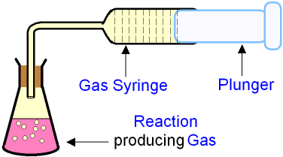

*Figure 1: Gas Generating Apparatus*

**Part A: Collect and Test Hydrogen and Oxygen Gasses**

1. Set up your **hydrogen gas** generator (see fig 1):
   1. Add a spoon full of mossy zinc to an Erlenmeyer, followed by 20mL of 3M hydrochloric acid which will start the reaction. *Allow the reaction to progress for 30s to purge air from the flask.*
   2. Insert the stopper and connect the tubing to the flask and the syringe. As pressure builds, the syringe will inflate on its own. Keep the apparatus connected until you have filled the syringe with gas, at which point you should remove the syringe and set it to the side until required. **Label this syringe “Hydrogen”**
2. Set up your **oxygen gas** generator (see fig 1):
   1. Add 4 droppers full (approximately 10 mL) of yeast suspension to a second Erlenmeyer flask, followed by 20 mL of hydrogen peroxide, which will start the reaction. *Allow the reaction to progress for 30s to purge air from the flask.*
   2. Insert the stopper and connect the tubing to the flask and the syringe. As pressure builds, the syringe will inflate on its own. Keep the apparatus connected until you have filled the syringe with gas, at which point you should remove the syringe and set it to the side until required. **Label this syringe “Oxygen”**

*Note: One syringe full of each gas may be enough to complete the experiment. If more oxygen and/or hydrogen is required, the reactions can be replenished and more gas collected.*

1. Check your two marked pipet bulbs.
   1. *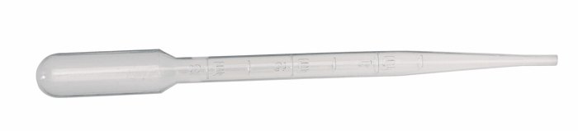Note: The lab assistant has calibrated your pipet bulbs by dividing them into 6 equal parts to allow you to collect specific ratios of gas. If these markings are faded or hard to see, ask for assistance.*

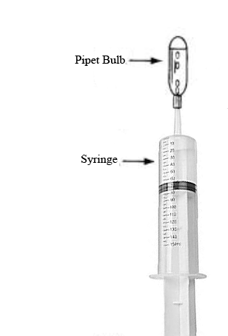**Part B: Test oxygen/hydrogen gas mixtures to find the best ratio.**

*Figure 2*

*You are now ready to find the most explosive ratio of Hydrogen:Oxygen.*

1. Completely fill a marked pipet bulb with **water** from the distilled water bottle.
   1. Attach the narrow filling spout to the **hydrogen** syringe (see fig 2) and hold the syringe upright, with the ***spout pointing towards the ceiling***.
   2. Place the pipet bulb on top of the spout, and slowly depress the syringe. Bubbles of gas will rise up into the bulb and displace the water (do this over the sink as your hand will get a bit wet – it’s just water).
   3. When the bulb is full, place a finger over the mouth of the pipet to prevent the gas from leaking out
2. 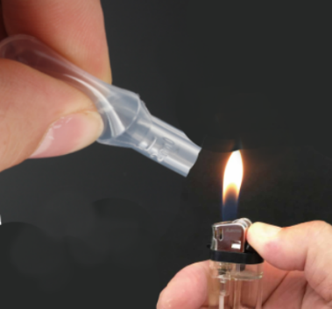Hold the gas bulb so the opening is pointed horizontally and have a classmate quickly strike the lighter over the opening of the bulb while ***gently squeezing*** the bulb. Record the results of this “pop test”.
3. Repeat steps 4-5 for the **oxygen** syringe, and record any “pop” results heard in your data table.

**Finding the best ratio**

1. Fill a marked bulb again, but this time collect only 1/6 oxygen, then use they hydrogen syringe to fill the remaining 5/6 of the bulb. This will be a 1:5 ratio of oxygen:hydrogen. Perform the pop test again, and record the data in the chart.
2. Repeat step 7 to collect and test other volume ratios (2:4, 3:3, 4:2, 5:1) of oxygen and hydrogen (see the data table). Always collect oxygen first, followed by hydrogen. Record all results in the data table.
3. Rank the gas mixtures on a scale from zero to 10 to describe their relative loudness in the “pop-test”. Let the most “explosive” mixture be a 10, and the least reactive gas mixture a zero. *Note: This is a subjective test, but by repeating several times with each mixture, it should be possible to determine the most explosive (loudest) mixture.*

**Rocket Launches**

1. Collect the optimum (loudest) gas mixture one more time, and bring it to the instructor. Your instructor will place the bulb on a rocket launch pad and ignite it with a piezo sparker. How far does the micro mole rocket travel?
2. Collect the optimum mixture again, but this time leave about 1ml of water in the bulb. With your instructor’s consent, launch the micro mole rocket.

**Data**

1. Explain the results of the
   1. Pure oxygen test
   2. Pure hydrogen test
2. Write the balanced chemical equation for the combustion of hydrogen and oxygen to give water.

*When the reactants in a mixture are present in the exact mole ratio given by the balanced chemical equation, all of the reactants should be used up when the reaction is over. However, if one of the reactants is present in an amount greater than its mole ratio, then the reactant cannot react completely, and some of it will be left over (“excess”), at the end of the reaction.*

1. Use the mole ratio of hydrogen:oxygen in the reaction above to determine what happens when various hydrogen/oxygen gas mixtures are allowed to burn. Complete the following table to indicate which reactant will run out first (the limiting reagent), which one is left over (the excess reagent), and how much excess will remain after the reaction is complete. *Note: one column is completed as an example.*

|  |  |  |  |  |  |  |  |
| --- | --- | --- | --- | --- | --- | --- | --- |
| **Parts H2** | 6 | 5 | 4 | 3 | 2 | 1 | 0 |
| **Parts O2** | 0 | 1 | 2 | 3 | 4 | 5 | 6 |
| **Limiting Reagent** |  | **O2** |  |  |  |  |  |
| **Excess Reagent** |  | **H2** |  |  |  |  |  |
| **Parts of excess remaining** |  | **3** |  |  |  |  |  |

1. Which ratio was the most explosive? What evidence did you use to find this?  
     
   1. Explain why, at the molecular level, this mixture was the most explosive,
2. Why, at the molecular level, did the bulb fly across the room?
3. Why did the oxygen and hydrogen not react as soon as they were collected?